Module Name: Login
Test Case ID: SD_TC_001
● Scenario ID: 1a
Scenario: Sign up with valid credentials
Test Steps: 1. Open orange HRM
2. Enter valid username & password
3. Click Login
Scareenshots:
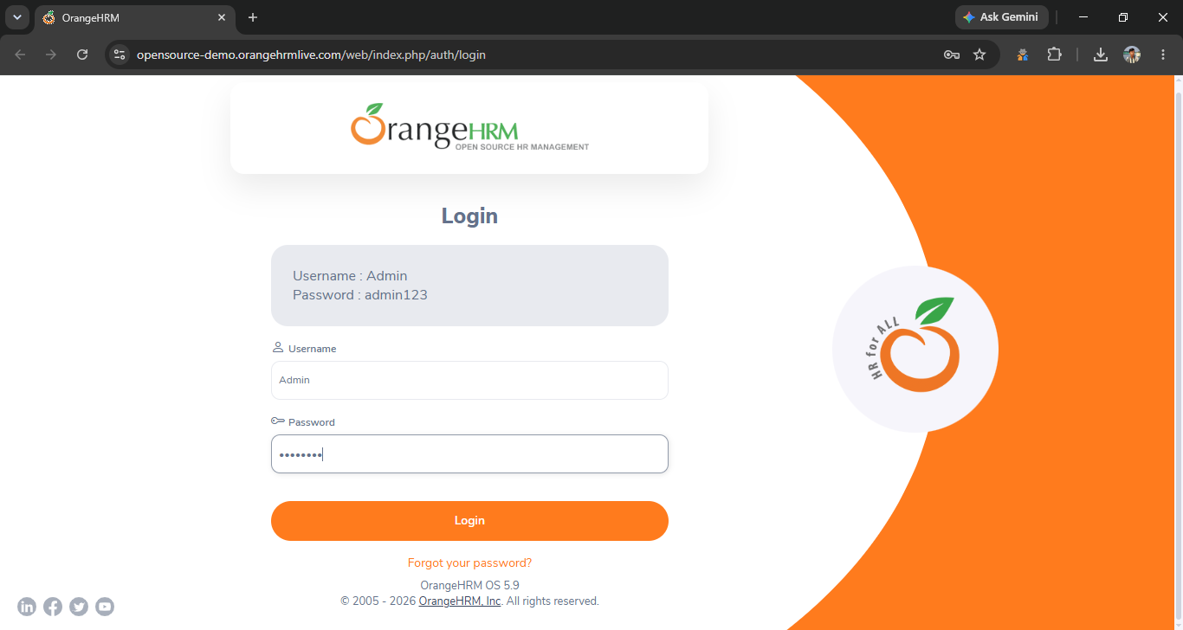
. scenario id 1b
login with wrong user name
test step
1 user name seth
2 password 123
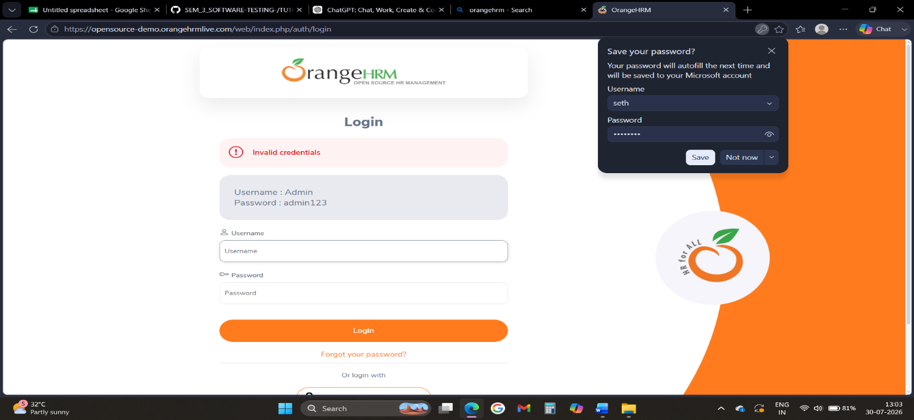
. scenario id:1c
Scenario: login with wrong password
Test step:
1. Ener valid user name
2. wrong password
Screen sort
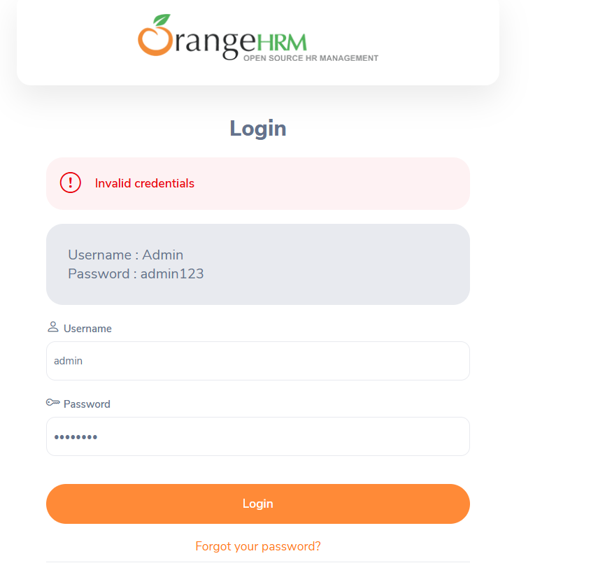
Scenario id 1d
Scenario:
Forgot password
Test step:
tap to forgot password
screen sort
